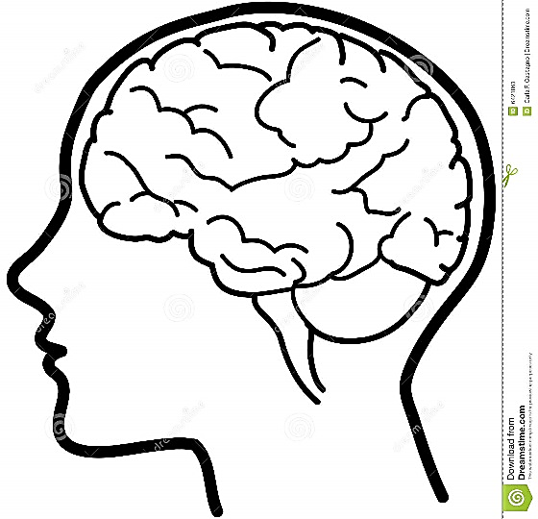
DOING
Empathy Map
SAYING
THINKING
FEELING

