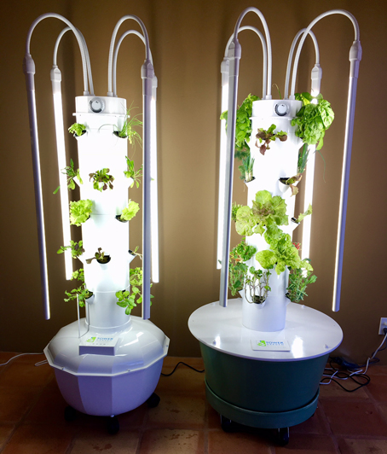
Starting Your Tower Garden

Starting Your Seeds

- Soak the rock wool starter cubes for 30 minutes.
- How many seeds per hole?
  - Gourmet Lettuce: 6 – 12 seeds
  - Herbs: 6 seeds
  - Vegetables with larger seeds (tomatoes, cucumbers, peppers, beans): 1 – 2 seeds
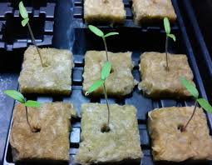
- Once you place the seeds, fill each hole with vermiculite.
- For smaller seeds, only fill the hole half full.
- Gently sprinkle a little water over each hole.
- Add a little water in the bottom of the container.

Filling Your Reservoir

- Fill reservoir with a hose.
- Chlorine in the water will evaporate over time (if you let it sit).
- Your Tower Garden will hold approximately 20 gallons when filled to within 3 inches of the top lid (do not overfill).

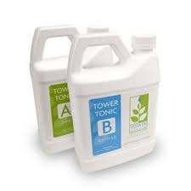
Adding Nutrients

- Use a large stirring paddle or spoon to mix the nutrients and pH adjusting chemicals in the reservoir.
- Add 20 mL of Mineral Blend A and 20 mL of Mineral Blend B with each 1 gallon.
- Tower Garden will hold approximately 20 gallons.
  - 20 mL (Mineral A) x 20 gallons = Add 400 mL (Mineral A) when adding nutrients to a full reservoir.
  - 20 mL (Mineral B) x 20 gallons = Add 400 mL (Mineral B) when adding nutrients to a full reservoir.
- Use half-strength nutrients for small seedlings.
  - 10 mL (Mineral A) x 20 gallons = 200 mL (Mineral A).
  - 10 mL (Mineral B) x 20 gallons = 200 mL (Mineral B).
Maintaining Your Tower Garden

Checking the water level – regularly

- The reservoir should always be at least half full.

Checking the pH - weekly

- Follow package instructions – (1) put reservoir water into pH testing tube, (2) use testing kit drops as directed, and (3) match colour of water with pH colour chart.
- The optimal pH range is 5.5 to 6.5.
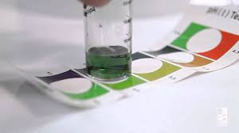
- If an adjustment is necessary, add one teaspoon (5mL) to either raise (pH+Base) or lower (pH-Acid) the pH.
- *Yellowing leaves are an indication that your pH may have drifted out of the recommended range.

Adding nutrients – when you fill the reservoir tank

- Cool months – add nutrients to the water every time you fill your reservoir tank.
- Hot months – add nutrients every other time you fill your reservoir tank (or half strength each time).
- Half-filled reservoir tank = 10 gallons.
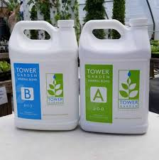
- Adding nutrients to 10 gallons (half-tank).
  - 20 mL (Mineral A) x 10 gallons = 200 mL (Mineral A) when adding nutrients to a half-filled reservoir tank.
  - 20 mL (Mineral B) x 10 gallons = 200 mL (Mineral B) when adding nutrients to a half-filled reservoir tank.

