Overview of Worm Composting

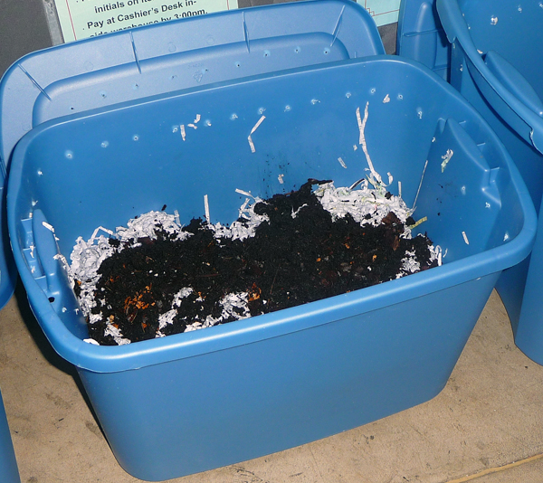
- Worm composting is the process of using worms to recycle food scraps into soil amendments called worm compost (also called; vermicomposting, worm castings, and worm poop).
- *Soil amendments – any material added to soil that supply nutrients and/or organic matter that improves its structure, such as; peat moss, compost, manure.
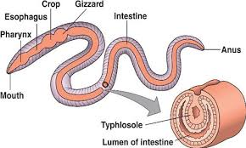
- Worms eat and digest food scraps, and the nutrients in those food scraps are converted into forms that can be used by plants. It is the trip through the worm’s digestive system that makes the nutrients usable to plants.
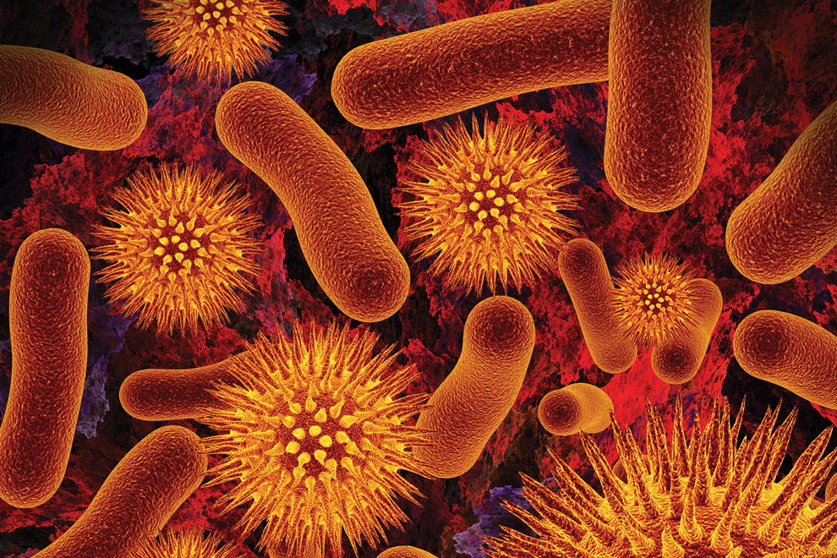
- Worm compost also increases the good microorganisms in the soil that can help stop plant diseases and repel insect attacks.
- *Microorganisms – are tiny single-cell organisms, like bacteria and fungi, that can do good or bad things in your garden.
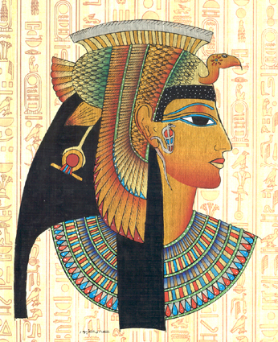
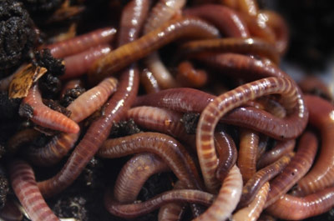
- Red wigglers are most commonly used for vermicomposting. The average life span of a red wiggler is almost two years, and the population doubles every three months (they reproduce quickly!). They can tolerate a wider temperature range than other worms. They are also beneficial because they feed on the surface (epigeic), unlike other worms that burrow into the ground and feed on soil.
- The Egyptians were one of the first cultures to recognize the potential uses of worm composting. In 50 BC, Cleopatra made worms sacred and created laws that made it illegal to remove them. The crime was punishable by death!

