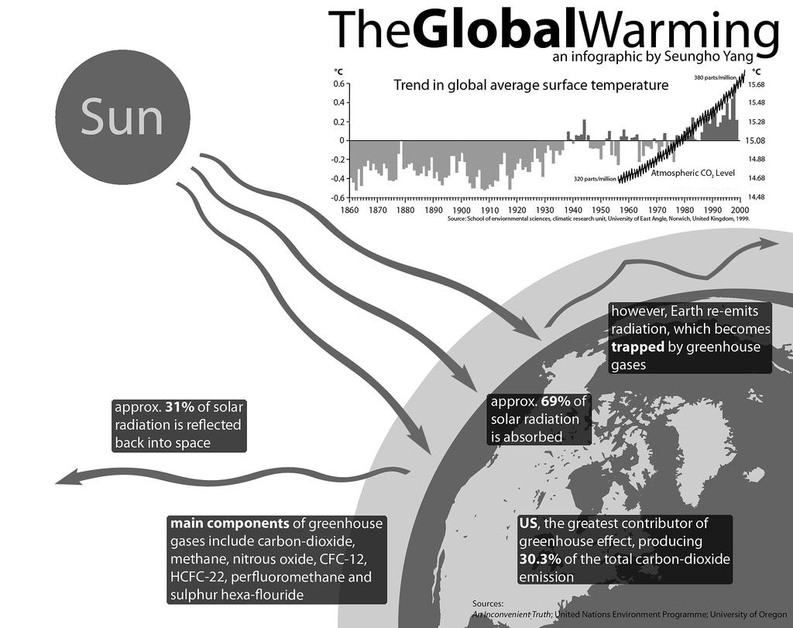
All rights reserved by Seungho Yang http://sixrevisions.com/graphics-design/40-useful-and-creative-infographics/

