Your Climate Action Plan
This activity would be a great lead-in to a final inquiry or passion project. Once students have a solid understanding of climate change, its causes and the positive impacts that humans can have, this activity can help students transition their thinking to actionable change.
Background:
We can all play a role in the climate movement by tapping into our skills, resources and networks in ways that bring us satisfaction, says climate leader Ayana Elizabeth Johnson. She suggests drawing a Venn diagram to map these questions: What are you good at? What is the work that needs doing? And what brings you joy? Where your answers intersect is where you should put your climate action effort. “Averting climate catastrophe: this is the work of our lifetimes,” Johnson says.
Activity:
- Watch: “How to Find Joy in Climate Action”
https://youtu.be/VsOJR40M0as?si=lasahpqUobafFO4W
- Students can then begin filling in their own Venn Diagram (attached)
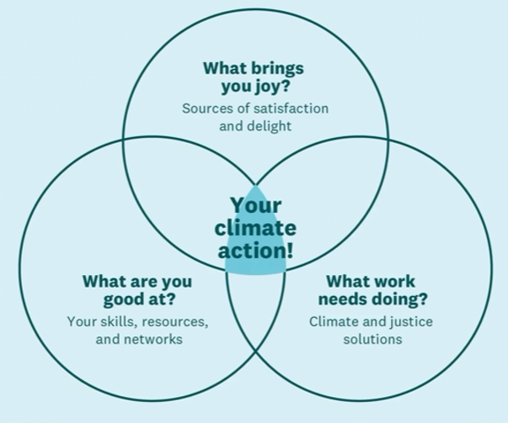
- Points for discussion:
What are you good at?
- Tie into competencies (curricular and core)
What work needs doing?
- Local or Global issues
- Ex. Systems level changes, composting, insulation, restoring wetlands, electrify everything, getting climate candidates elected…
What brings you joy?
- Ensure they choose a passion, it’s the long haul!

Goal is to be at the heart of this Venn diagram for as many minutes per day as possible.

Sample Climate Action Goals (from the video)
- Create a climate action investing portfolio
- Write narrative magazine articles on how climate intersects with labor rights and immigration
- Create a “Climate Victory Garden” to convert lawn into a model for small scale regenerative farming
