From website: http://blog.classcreator.io/teaching-kids-to-struggle-growthmindset/

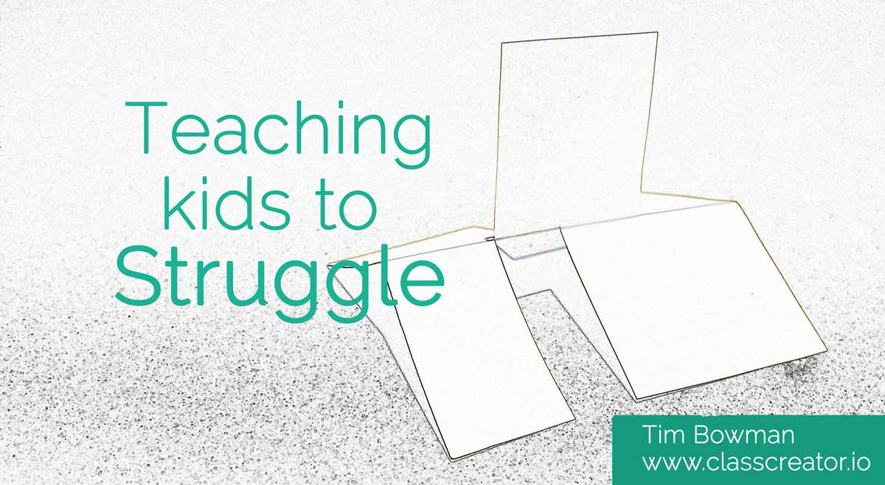
Teaching kids to struggle #GrowthMindset
Tim Bowman Feb 09, 2016 2 Comments

Why do kids need to learn to struggle?
As adults we all know the most rewarding experiences in life often involve significant struggle and sacrifice at some stage. Personally the greatest joys in my life have all come with some form of struggle…
Being married. We are very happily married, but that doesn’t mean we are always very happy with one another.
Being a parent. The most rewarding thing I have and will ever do…but where did my sleep go? (x100 for my wife)
Staying healthy. I like chocolate and since turning 30 my metabolism can’t burn 50,000 calories as easily as it used to.
Being a teacher. How do I motivate/help/manage/engage/inspire/avoid being stabbed by this student?
Without the ability to struggle life becomes very limited.
A fear of struggling will stop students from trying something they are not 100% certain they will succeed at with ease.
The list of things we know we can all succeed at in the adult world probably consists of 1) breathing 2) eating chocolate 3) sitting on the couch watching The Bachelorette.
Don’t get me wrong, I love The Bachelorette, but I hope people aren’t talking about it at my funeral.
So how do we help our students not just cope with struggle, but to thrive with it?

Here is one activity I have used to confront and discuss “Struggling” with my students…
Before your students enter the room place a couple of these (I’ll show you how to make it at the end of this post) in a place where each student can easily view it from all sides.
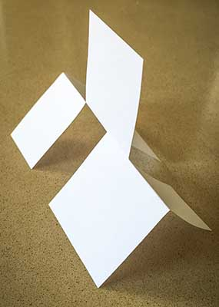
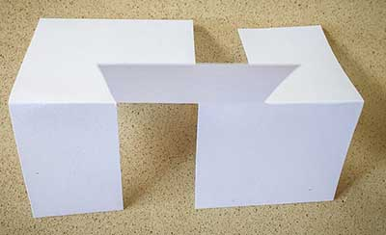

Students will need scrap paper and a pair of scissors to attempt to make the structure themselves.
Instruct students they cannot touch the structure, but they are encouraged to move around it and view it from all angles.
Encourage students to discuss their ideas and methods as they go, but if they are successful, they are to keep their method to themselves.
I recommend you don’t “prime” the students to be positive, just let them approach the task as they would any other.
Then the fun begins. Students are then challenged to make the structure. Don’t offer any advice or encouragement once the students begin. Just observe.
From my experience most students (90%) will not be able to make the structure within 10 minutes.
For the record I never figured it out...
My brother challenged me to make it one Christmas day and it nearly resulted in World War III until he finally told me the answer.
While the kids are working on it walk around the classroom and monitor their behaviour and language. I write down the language I hear and take photos of the kids working.
After seven or so minutes I start writing the language I have heard on the whiteboard, with no names attached. I don’t say anything while I write all the language on the board. Some kids stop and read, others keep doing what they’re doing. If a student says something else interesting as I write that goes up as well.
Once you think the kids have had enough get them to stop building and turn their attention to the board.
`

Ask students to share how they felt during the activity
- Did anyone make it? How long did it take? How many tries?
- Was the first ten seconds of trying much different from the last ten seconds? How? Why?
- What was it like when someone else got it?
- How many attempts did you take?
- How long did you look at the structure before you first started?
- How many breaks did you take?
- Did you look at what other people were doing? Why? How did it make you feel? Did you learn anything from what they were doing?
Then turn your attention to the language you recorded. I try and remove ownership of the language and then use the language as the personification of a person. We discuss how that “person” would fare in a:
- football match
- job interview
- audition for dance company
- on MasterChef/X-Factor
- relationship
- any challenge relevant to your students
We discuss how life is full of frustrating, annoying, unfair situations that often appear too difficult for us to overcome.
We talk about how everyone has different strengths, and as a result we all face different challenges, but the one thing that we have in common is that we will all struggle at some stage in our life.
I then refer back to the language used during the activity and how the language we tell ourselves quickly becomes our own best friend or worst enemy.
If students can start to reflect on the language they use about themselves at a young age, and choose a better path, it is a fair bet their lives will be more productive and fulfilling.
“I can’t do this” vs “I can do this, I just haven’t figure it out yet”
“He is smarter than me because he already has finished” vs “I wonder if there is anything I can learn from his approach”
“I give up” vs “How can I approach this differently?” or “It’s ok that I can’t get it right now, but I can keep trying”
For me a student’s mindset is the most important element to their success, both in the short and long term.
Obviously you can use this same “Record and Discuss” strategy for any activity that involves a struggle for your students.
If we can help a student feel more comfortable with struggling, we can break them free from the fear of “having a go”.

How to make it:
Step 1: Use a rectangular piece of paper. I’ve got my Class Creator business card here to show the twist in Step 5.

Step 2: Fold the paper in half along the long side, the fold it back out flat again.
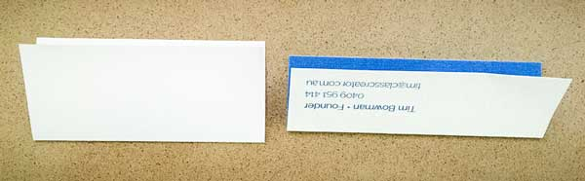
Step 3: Make the cuts below to the middle. (Two on one side, one on the other)
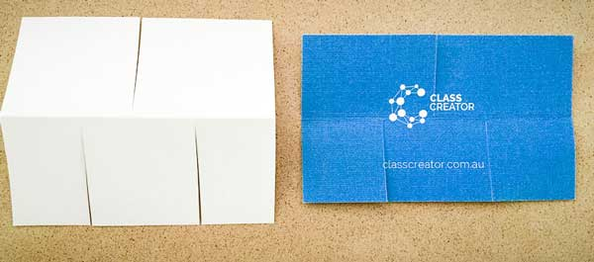
Step 4: Here is the “tricky” part. You have to twist the paper. That’s why I used my business card, so you could see the different colours as a result of the “twist.
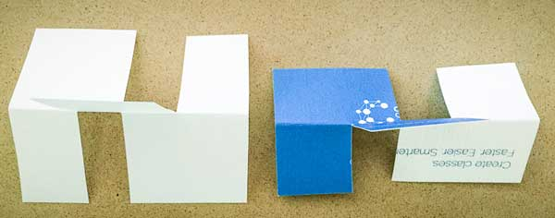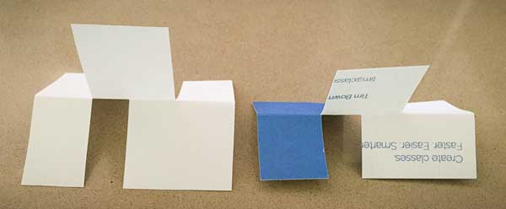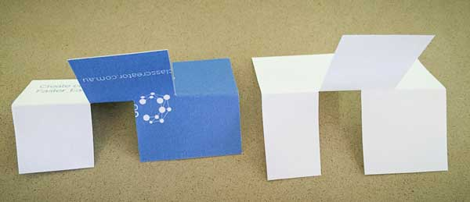
I hope this blog post give you a few ideas. If you put it into action please send me an email or leave a comment below.

