Global Citizenship Inquiry-Based Project
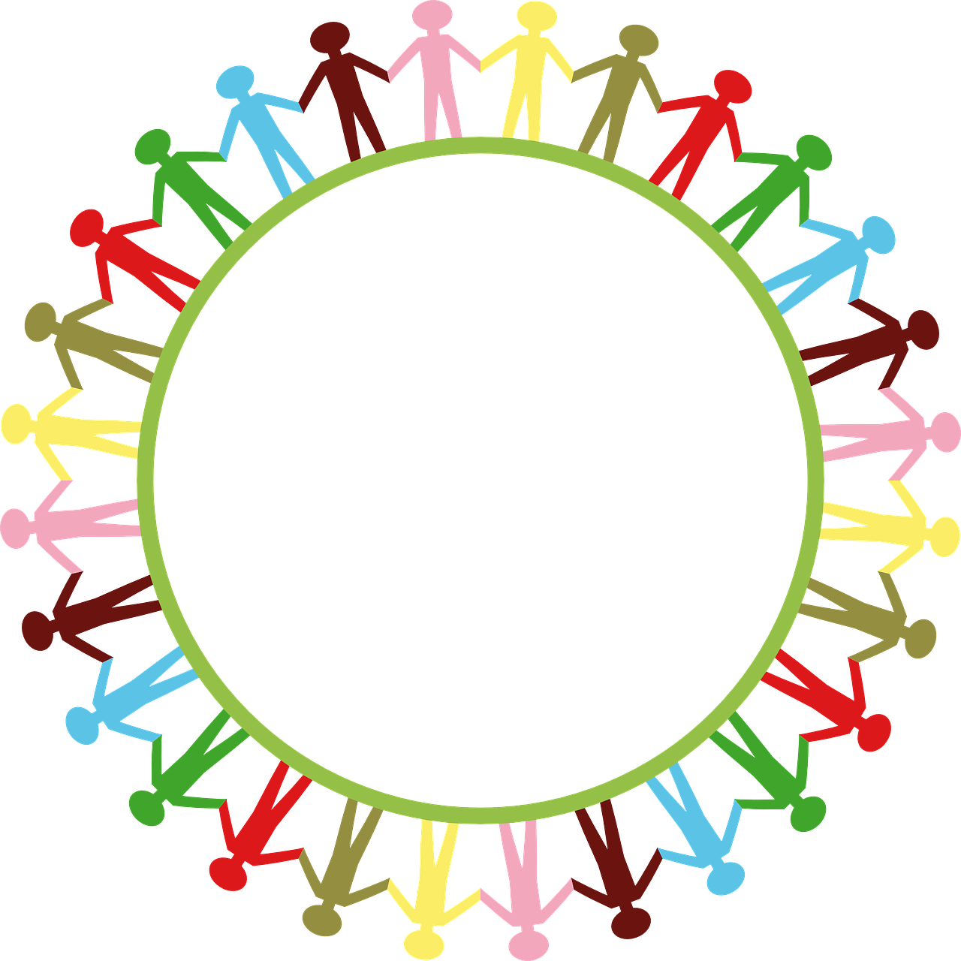

Name(s): _______________________________
Due: ______________

Task:
You will complete an inquiry-based project on a GLOBAL GOAL of your choice. Your focus will be overall, how global goals impact humans? When choosing a global goal, be sure to pick something you are interested in learning about – that way the project will be more impactful.
The purpose of this project is to help you develop your critical thinking skills, empathy, research skills, your ability to assess your own learning, referencing sources of information, and your presentation skills.
Inquiry based learning is a process where students are involved in their own learning.
The inquiry model involves the following steps:
- Planning
- Gathering information
- Processing information
- Creating a product (INFOGRAPHIC on Canva)
- Sharing new information
- Reflecting on your learning
Project:
Your project has two parts. The first part will involve choosing a global goal that you are interested in learning more about.
Research:
You need to find information from Reputable Websites, books, videos, interviews, newspapers, etc… Keep a working bibliography as you go through your research. You will then use the information you gathered and processed to answer your “Essential Question.”

Essential Question:
- Requires you to make a judgement, formulate your own (educated) opinions,
develop a plan of action or make a decision.
- Will tie into real world problems/issues/events and must be meaningful, relevant and interesting
- Have no right or wrong answers, but can be answered

Prompts:
- Who/what has had the biggest impact…
- What plan could be developed to…
- What should be done to…
- What is the best way…
- How to compare…

Brainstorm Section for Essential Question:

TIMELINE:

TASK | DUE DATE | Checklist
Inquiry Research Goals
Essential and Guiding Questions Written
Research Completed
Creating your Infographic
Final Project Due
Presentation Date

Inquiry Research Project: Research Goals
1. What do I already know about this topic?

2. What do I need or want to know about this topic?

3. What skills do I want to focus on?
Questioning & Predicting Planning & Conducting Evaluating
Applying & Innovating Processing & Analyzing Critical thinking
Creative thinking Communication Social Responsibility

Explain:

Inquiry Research Essential and Guiding Questions
Essential Question: ______________________________________________
Guiding Questions are ones that need to be answered in order for you to be able to answer your Essential Question. These are the questions that will guide your research. In other words, what do I need to know about my topic?
Write 3-4 Guiding questions below.
1)

2)

3)

4)
RESEARCH:
1) Guiding Question: _________________________________________
Notes:

Bibliography (where did I get my notes from?)

2) Guiding Question: _________________________________________
Notes:

Bibliography (where did I get my notes from?)

3) Guiding Question: _________________________________________
Notes:

Bibliography (where did I get my notes from?)

4) Guiding Question: _________________________________________
Notes:

Bibliography (where did I get my notes from?)

Answering your Essential Question – INFOGRAPHIC
Cocreated Rubric

Final Reflection
In paragraph form, reflect on each of the following. Your answers should be supported with detail and evidence.
1. Describe something meaningful that you accomplished during this project. Identify what that action or choice was and why it is significant to you.

2. What challenges did you face along the way? Identify 1 or 2 of these struggles and reflect on how you overcame or dealt with them.

3. Share any lingering questions or wonderings that you still have after completing your research.

4. Describe your key insights or takeaways from this project. Think about what you learned about the process of research and inquiry, the topic or you as a learner.

Competencies:
Communication
Students inquire into topics that interest them, and topics related to their school studies. They present for many purposes and audiences; examples include “show and tell,” explaining a concept, and sharing a presentation about a research/inquiry topic
□ I can understand and share information about a topic that is important to me.
□ I present information clearly and in an organized way.
□ I can present information and ideas to an audience I may not know.
Critical Thinking
Students learn to engage in an inquiry and investigation where they identify and explore questions or challenges related to key issues. They develop and refine questions; create and carry out plans; gather, interpret, and synthesize information and evidence; and draw reasoned conclusions. They will also consider purpose, focus on evidence, and draw conclusions and make defensible judgments or assessments
□ I can analyze evidence from different perspectives.
□ I can reflect on and evaluate my thinking, products, and actions.
□ I can ask open-ended questions and gather information.
□ I can evaluate the credibility of sources of information.
□ I can tell the difference between facts and interpretations, opinions, or judgments

