Worm Compost Care


- Red wigglers like cool and dark places, so it’s important to set up your worm composting system in a controlled environment, especially if your area experiences extreme changes in temperature.

- If your compost system is outdoors, and there is a chance of freezing temperatures, move it indoors.
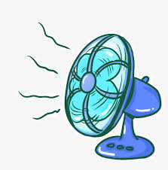
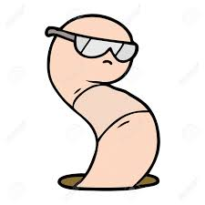
- If it’s hot and dry, keep your worm composting system in a shady place and place a soaked newspaper over the top of the container to help keep them cool.
- Red wigglers must be kept moist (not damp) to survive. This is why bedding is important. To help keep the worms moist and productive, place a soaked newspaper over them to help retain moisture in the bedding.
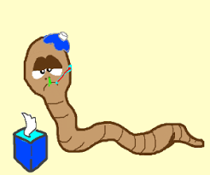
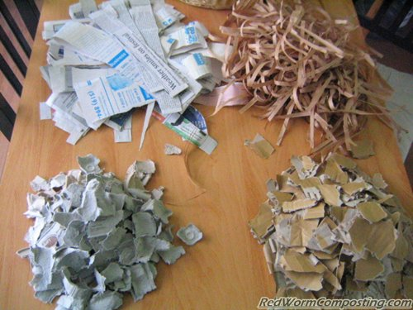
- *Bedding – Worm bedding is a long-term food source for worms (50% of food source). Good bedding must retain moisture, allow oxygen to flow, not be sharp or abrasive, and be of neutral pH. Bedding materials include; shredded brown cardboard, shredded paper (not bleached white office paper), shredded newspaper (not coloured), aged compost, aged horse or cow manure, coco coir, peat moss, straw and hay, fall leaves and other yard waste, and wood chips. *Always dampen materials before you add them.
- You also need to feed them the right quantity of food scraps. Over-feeding can cause problems in the bin, such as; causing odors, acidity, excess moisture, pests and sick worms.
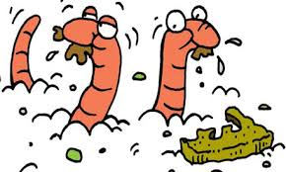
- The worms should start working on a feeding within a few days and probably finish it within 1 to 2 weeks. If you see large amounts of undigested organic material after this time, you are probably overfeeding.
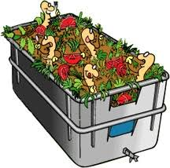
- Under ideal conditions, worms can eat half their weight in scraps per day. So, if you have 2 pounds of worms, they can theoretically eat 1 pound of scraps. However, it is recommended you play it safe by feeding an amount they can handle every 2 or 3 days.
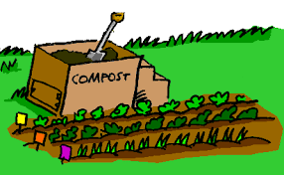
- Stop putting food in once the top bin is full, and wait for all the food to be broken down into compost. After all the food is broken down, put that top bin in the middle position, and fill the new top bin with bedding and food scraps. The worms will travel through the holes into that new top bin with the food and bedding, leaving behind the worm compost.

