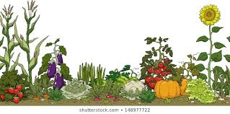
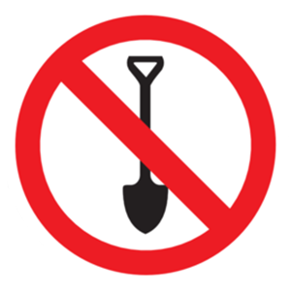
No-Dig Gardening – Steps

- Pitchfork holes into the soil (loosen soil to allow water and oxygen to enter).
- Fertilize area with blood meal, bone meal, and lime (help grass decompose and enrich soil).


- Layer newspapers (10 layers thick) or cardboard (stop weeds).
- Add 7-10 cm of Lucerne/Alfalfa Hay (adds lots of nitrogen and decomposes quickly).


- Add 5 cm manure/compost (can also add kitchen scraps, rock dust, worm castings etc.)

- Add 7-10 cm of Straw.
- Add another 5 cm manure/compost.

- *Bonus: Add another layer of newspapers (stop weeds in manure/compost).
- Add another 7-10 cm of straw.

- Dig a hole into straw, add more compost, and plant! 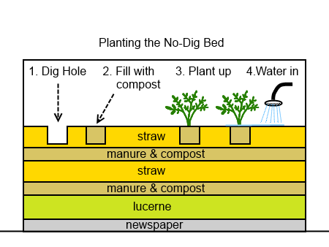
*Bonus: extra layer of newspapers to stop weeds.


Benefits of No-Dig Gardening

- No digging!
- The beneficial organisms in the soil that help plants grow are not disturbed by digging.
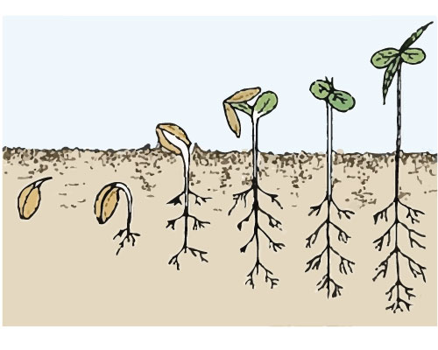
- Beneficial organisms – earth worms, fungi, and bacteria.
- The weed seeds in the soil are not brought up to the surface to grow by digging.
- There are fewer weeds to remove because the straw (mulch)blocks them from growing.

How to Prepare for the Next Growing Season


- Add a layer of manure/compost.
- Cover the manure/compost with straw.
- Water it in.

Glossary

- Fertilize – Adding the nutrients that plants need to live (humans also need similar nutrients).
- Three Main Nutrients – needed by plants for growth are nitrogen (N), phosphorus (P), and potassium (K).
Other important nutrients are calcium, magnesium and sulfur.
- Blood Meal – Powder made from animal blood (high-nitrogen organic fertilizer)
- Bone Meal – Powder made from animal bones (organic fertilizer that adds phosphorus to garden soil. It also is a good source of calcium).
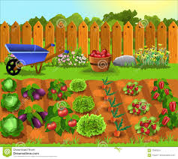
- Lime – Used to correct soil pH. Using lime for acidic soil raises the pH so plants can take up nutrients.
- Rock Dust – Powder made from crushed rock that provides important minerals to plants.

