The Greenhouse Effect
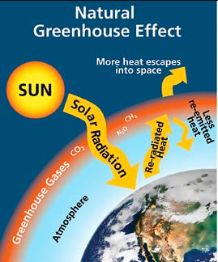
The Natural Greenhouse Effect is a process that occurs when gases in the Earth’s atmosphere trap the sun’s heat. It is a natural process that keeps our atmosphere warm so that plants and animals can live.

The Enhanced Greenhouse Effect is caused by emissions and other chemicals that have been put into our atmosphere from burning fossil fuels and other forms of pollution. These chemicals trap extra heat which causes our atmosphere to warm up significantly. We are currently seeing the impacts of the Enhanced Greenhouse effect and climate change/global warming.
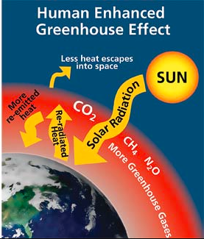

What reduces the Enhanced Greenhouse Effect?
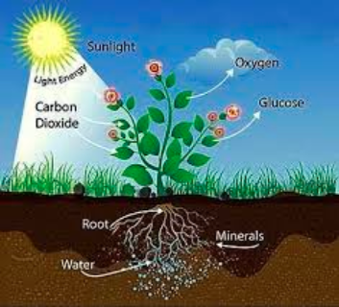
PLANTS! All plants, from giant trees, to phytoplankton in the oceans all help. How?

The process of photosynthesis takes carbon dioxide out of the atmosphere and produces oxygen.
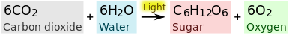

GOAL:
For you to understand
- The positives and negatives of the greenhouse effect
- The role plants play in reducing the greenhouse effect

